***10th Anniversary Edition***

**Bexar County**

**Restorative Foster Care Courts: PEARLS & EAGLES**

**2024-2025 Annual Report**



Dear Community Partners and Friends,

**Message from our Presiding Judges**

    This year marks a powerful milestone—**the 10th Anniversary of PEARLS Court.** What began as a dream to *heal, love, and inspire* teen girls in foster care has now matured into a comprehensive, restorative model of support that continues to transform lives.

    Since assuming leadership of PEARLS Court in 2019, we’ve watched the program grow in depth and reach. We expanded our mission with the creation of **EAGLES Court**, extending trauma-informed, relationship-centered services to male youth in care. Our Restorative Foster Care Courts have become a model of what’s possible when courts, community partners, and committed volunteers come together with a shared belief:our youth are worthy of investment, support, and the opportunity to thrive.

    Over the past decade, **more than 250 young people** have participated in PEARLS and EAGLES. Through counseling, mentoring, skill-building, and consistent court engagement, they have achieved tangible outcomes—graduating high school, entering college, achieving placement stability, deferring early parenthood, and gaining tools to manage trauma. Even more powerful than the data are the stories: the youth who found their voice, rebuilt trust, explored leadership, and dared to envision a future beyond the shadows of their past.

    With the continued support of our partners including DFPS, CASA, BCFES, and community volunteers, our courts now offer a **full continuum of trauma-informed services**. We emphasize education, prevention, and healing while guiding each youth through a tailored, restorative court experience.

    Our youth have participated in college visits, community service, career exploration, and therapeutic group retreats. They stood in courtrooms, not to be judged, but to be *seen*—for their strengths, their resilience, and their growth. As always, our outcomes reflect this commitment, as indicated in our annual report herein.  You will find our programs foster academic progress, support stabilized placements, and promote healthy choices—all while building relationships rooted in safety and mutual respect.

    As we reflect on a decade of impact, we are also looking forward. We’re proud to have supported the launch of PEARLS in Harris County, and we remain committed to mentoring and scaling restorative models wherever there is need. As always, we are inspired by the courage of the youth we serve and the dedication of those who walk alongside them.

Thank you for continuing to believe in this work. Thank you for standing with us, and with them. We invite you to celebrate this 10-year anniversary not just as a milestone, but as a **renewed call to action**: to show up, to invest, and to remind these young people that their story is still being written—and that it can be powerful, joyful, and whole.

With gratitude,

***Judge Rosie Alvarado*** *&* ***Judge Angelica Jimenez***

**The Challenge**

In 2024, there were **3,157 children in conservatorship** care in Bexar County. **896** of them were between the ages of 12 and 18. Children in the foster care system face many challenges:

* **97%** live in poverty or worse after exiting care
* **Only 3%** earn a college degree
* **1 in 5** are incarcerated within 2 years
* **70%** of girls become pregnant before age 21
* **50%** struggle with substance dependence
* **1 in 6 girls** are victims of sex trafficking or prostitution

*Aecf.org*

**Court History**



PEARLS Court was founded in 2015 by Judge Renée Yanta and initially operated solely with the support of dedicated volunteers. In January 2019, Judge Rosie Alvarado and Judge Angelica Jimenez assumed judicial leadership of the court. To expand the impact of this model to male youth in care, EAGLES Court was established in 2020, with Judge Nadine Nieto and Judge Raul Perales currently presiding.

Together, PEARLS and EAGLES Courts comprise the Restorative Foster Care Courts of Bexar County. These specialized courts are supported by a multidisciplinary team that includes a Court Manager, two Court Monitors, licensed therapists, and a strong base of committed volunteers.

To further sustain and enhance the mission of these courts, the PEARLS Foundation was created. The foundation is led by Judge Yanta and Judge David Canales and continues to champion the well-being of youth in foster care through advocacy, community engagement, and resource development.

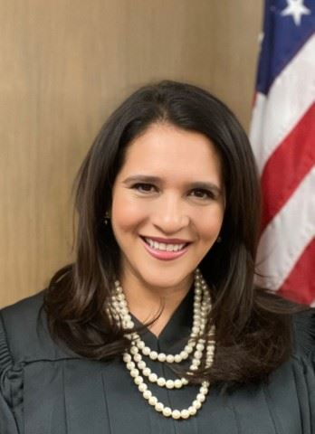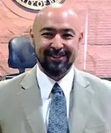

**EAGLES**

**Presiding Judge**

**Nadine Nieto**

**285th Civil District Court**

**PEARLS**

**Presiding Judge  
Rosie Alvarado**

**438th Civil District Court**

**PEARLS**

**Presiding Judge  
Angelica Jimenez**

**408th Civil District Court**

**EAGLES**

**Presiding Judge**

**Raul Perales**

**Associate Judge**

**Our Mission**

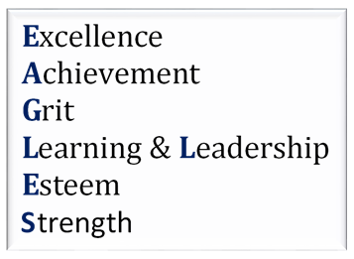The Restorative Foster Care Courts are dedicated to helping youth recognize their inherent value and strengths. The mission is to support healing from past trauma, foster resilience, and promote educational and placement stability, all while encouraging the development of healthy, supportive relationships.

To achieve these goals, the courts offer a comprehensive continuum of gender-responsive services designed to build character and address the complex needs of youth in foster care. These services include:

* Trauma-informed care
* Life-skills training
* 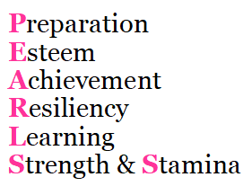Mentorship and relationship-building
* Mental health treatment
* Domestic violence awareness and prevention
* Teen pregnancy prevention
* Substance abuse prevention
* Resiliency and self-esteem development

This holistic approach empowers youth to navigate their futures with confidence, stability, and support.

**The Court Process**

The Restorative Foster Care Courts serve youth in foster care between the ages of 12 and 18 who are under Permanent Managing Conservatorship (PMC) in Bexar County. The program takes a personalized, trauma-informed approach by developing individualized treatment plans for each youth. These plans focus on building internal strengths and empowering youth to successfully transition into adulthood.

**Quarterly, youth participate in personalized court hearings identified as Permanency Hearings.**

The courts implement treatment plans through a three-pronged approach:

1. **Therapeutic Group Counseling**
2. **One-on-One Mentorship** with trauma-informed mentors
3. **Resiliency Training** through structured life skills development

Support continues beyond a youth’s time in care. Upon aging out, youth are connected to a network of community partners and resources, including Thru Project, BCFES, PALS BCFS, Alamo Colleges, Texas A&M–San Antonio, and UTSA, to ensure a stable and supported transition into independent adulthood.

**The Court Program**

Twice a month, youth participate in group sessions alongside peers, mentors, and court staff. These sessions—facilitated by CLIMB—focus on developing essential life skills, engaging in therapeutic activities, building fellowship, and helping youth identify and harness their personal strengths to lead healthy, educated, and successful lives.

In addition to regular sessions, both courts provide enriching experiences designed to broaden youth perspectives and foster community involvement. Through **Days of Opportunity** and **Days of Service**, youth are introduced to new environments, encouraged to give back to their communities, and inspired toward a life of purpose, leadership, and service.

**Just a few examples…**

Days of Opportunity: college campus visits, leadership-focused camping trips and the Annual Career Festival

Days of Service: volunteering with Meals on Wheels, the SA Food Bank, Brookdale Senior Living Center, and Blueprint Ministries.

**Community Partnerships**

In addition to the commitment of our dedicated volunteers, our Courts are strengthened by deep, consistent partnerships throughout the Bexar County community. During this program year, we proudly collaborated with The University of Texas at San Antonio and the Bexar County Fostering Educational Success (BCFES) Climb Program.

We look forward to continuing and expanding our partnerships with organizations such as Texas A&M University–San Antonio, Blueprint Ministries, St. Mary’s School of Law, H-E-B, and NuStar Energy—along with many others who share our commitment to empowering youth in foster care.

Using a **Village Matching Model**, youth have the freedom to make choices about their mentor relationships and reclaim their voice in developing their supportive network.



**279 524 21 14**

**2024**

**Community Partnerships**

**2024**

**Volunteer Hours Donated**

**Total Youth**

**Reached**

**(since formation)**

**2024**

**Volunteers**

**Outcomes**

**49**

Youth were served through PEARLS & EAGLES Court

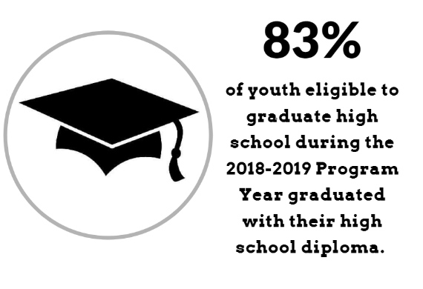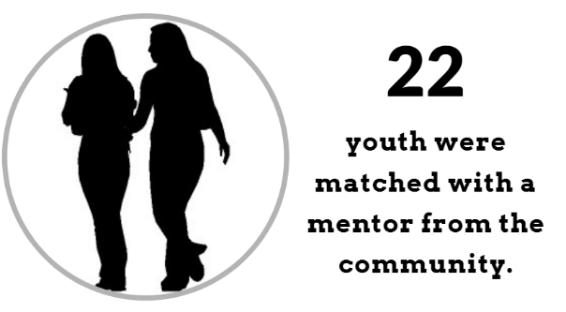

**63%**

Of graduating youth will enter higher education

**89%**

Of youth eligible to graduate high school graduated with their high school diploma.

**RFCC Court tracks the following outcomes of participants:**

|  |  |  |  |  |  |
| --- | --- | --- | --- | --- | --- |
|  | **Target** | **2021-2022** | **2022-2023** | **2023-2024** | **2024-2025** |
| Promoted to the next grade level | 80% | 90% | 92% | 83% | 86% |
| Progress toward a stable and permanent placement | 80% | 75% | 79% | 81% | 92% |
| Exhibit improved stress management | 90% | 95% | 95% | 81% | 92% |
| Choosing to post- pone parenthood | 80% | 98% | 90% | 98% | 98% |
| Avoid tobacco, alcohol, and unprescribed drugs | 80% | 80% | 78% | 79% | 89% |

“This program makes me feel seen, heard, and supported!”

**…………..…. What youth have to say about the program ……………**

“I love my mentor!”

“I have made many supportive connections!”

“I look forward to all of the events!”

“I love my PEARLS team!”

“I have made some really good friends! The judges and staff are so kind!”

“I learned so much about the career I’m interested in.”

**PEARLS and EAGLES Court Team**

**Please contact us if you have any questions!**

**We look forward to partnering with you!**

PEARLS Presiding Judges

**Judge Angelica Jimenez and Judge Rosie Alvarado**

EAGLES Presiding Judges

**Judge Nadine Nieto and Judge Raul Perales**

PEARLS Court Monitor

**Tatiana Dixon**

[Tatiana.Olveda@bexar.org](mailto:Tatiana.Olveda@bexar.org)

EAGLES Court Monitor

**Moses Gomez**

[Moses.Gomez@bexar.org](mailto:Moses.Gomez@bexar.org)

Court Therapists: **Kristeena Dewberry**

**Because every girl deserves to know she is a Pearl of great value.**

